JEWISH THOUGHT

Student Profile
Jordan Einhorn
p10
Meet the Department of Jewish Thought Faculty

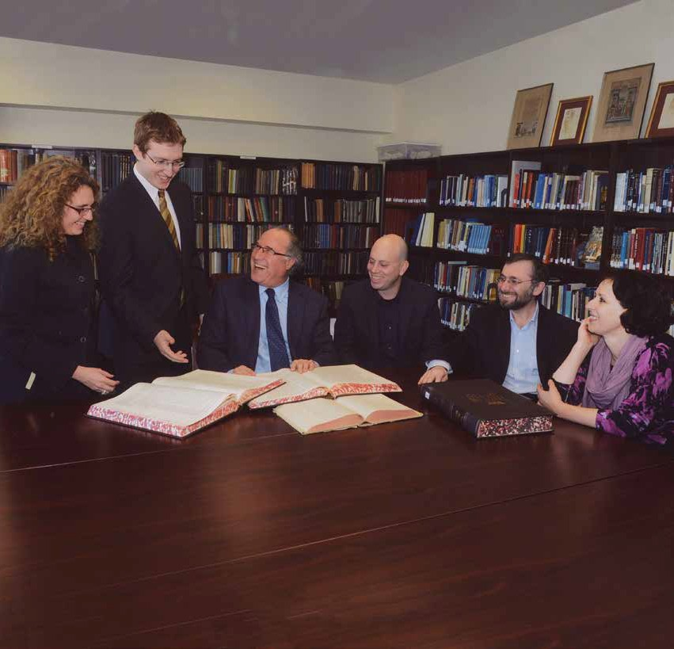
Newsletter 2015–2016

www.jewishthought.buffalo.edu
http://jewishthought.buffalo.edu/

DEPARTMENT ANNOUNCEMENTS

About the Department
In December 2015 the Department of Jewish Thought was created to serve as a multidisciplinary research and academic department focused on teaching and scholarship related to the contributions of the Jewish tradition in the development of Western civilization. Our mission is to foster knowledge, inquiry, and scholarly excellence to better understand Judaism, along with its contributions to a deeper understanding of current agendas and social challenges of humanity at large.
Throughout its long and diverse history, a central and unifying feature of Judaism is its emphasis on ethics, on biblical and rabbinic teachings of morality, and the prophetic call to justice. Nourished by the enormous spiritual, intellectual,
and cultural contributions of a long and productive history, and of a pluralist tradition which remains alive and vibrant in today’s world, the Department of Jewish Thought is especially attentive
to the grand tradition of Western philosophy and to contemporary literary theory and criticism.
We invite you to follow our growth as we strive to excel in teaching and scholarship.

EDITING STAFF
Directors: Valerie Bailoni, Professor Alex Green
Editors: Imani Whaley, Ashley Daley,

In this Issue:
3 ››
4 ››
5 - 7 ››

8 ››

9 ››

10 ››
11 ››

On the cover

Department News
› About the Department
› New M.A. Program
Message from the Chair
› Sergey Dolgolopski
Our Faculty
› Sergey Dolgolopski
› Richard Cohen
› Noam Pines
› Marla Segol
› Alex Green
Lectures and Conferences
› The Impact of Maimonides
› The Law in the Work of Franz Kafka
New and Upcoming Book Publications
› Out of Control: Confrontations between Spinoza and Levinas by Richard Cohen
› The Virtue of Ethics of Levi Gersonides by Alex Green

Student Profile
› Jordan Einhorn
Last Look
› Giving at UB
› Student Thank You Message

Craig Garaas-Johnson, Elin Hawkinson
Designers: Renee Ruffino, Jacob Schupbach
The Department of Jewish Thought faculty come together to discuss their recent work.

A new MA Program is on the Way
We are pleased to announce that in Spring 2016, SUNY granted University at Buffalo permission to create a Master’s degree program in the Department of Jewish Thought. This innovative new program will welcome students in pursuit of doctoral degrees, and plans to provide advanced learning for adults in Judaism. We wish to extend a special invitation to local learners in the Buffalo and Western New York area.

Our doors are also open to students from outside the US. In an attempt to attract the highest caliber of international scholar, we hope to seek and develop fellowship opportunities. As we continue to organize the administrative structure and course
requirements, support from our generous donors will be the key to creating these and other opportunities for future generations of UB students.

MESSAGE FROM THE CHAIR | SERGEY DOLGOPOLSKI

Sergey Dolgolopski, Department of Jewish Thought Chair and Gordon and Gretchen Gross professor
s chair, I am honored to launch the first full academic year of UB’s groundbreaking Department of Jewish
Thought. It is our aim to engage an
A
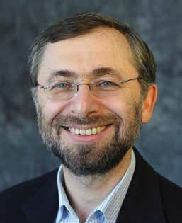
extensive and diverse population of students, researchers, and community members as we address a broad set of meaningful issues. We wish to reclaim anew the role of the Jewish intellectual tradition in and for Jews and Judaism, and—more broadly—in and for Western civilization as a whole. It is our belief that these are interrelated, and that our task is to expose,
analyze, and more deeply understand the treasures of these traditions.

This is an ambitious task. Fortunately, the Department has five world-class scholars who are working at the cutting-edge of their disciplines: rabbinics, medieval mysticism, medieval Jewish philosophy, modern and contemporary ethics, literary theory, and political philosophy.
It is humbling and exciting to serve as the Chair of a Department with such an intellectually cohesive and diverse body of faculty. The faculty translates their advanced and creative research into teaching for undergraduates and graduates. The department members are also active in community outreach events such as lecture series and local synagogues presentations.

I want to recognize Professor Kenneth Dauber of the Department of English, who initially articulated and defended the need for the academic study of Judaism
at UB. I would also like to commend Professor Richard Cohen, who shaped the initial vision of the Institute of
Jewish Thought and Heritage, directed it, lead the creation of the Department of Jewish Thought, and served as
its first Chair. Cohen’s outstanding scholarly contributions to the study of contemporary Jewish philosophy and ethics, and his achievements as Director and first Chair, continue to inform the Department in its future advances.
We are further indebted to the tireless efforts of administrative specialists Ms. Michele Bewley, Ms. Susan McNeill, and Ms. Valerie Bailoni, who worked with the faculty over different periods of time.

In the spirit of due appreciation, let me take this opportunity to thank donors who have already made generous contributions to our projects and initiatives. As we grow, financial support of our endeavors is more critical than ever. The Department of Jewish Thought aims to build on our long history of

“It is humbling and exciting to serve as the Chair of a Department with such an intellectually cohesive and diverse body of faculty in the upcoming year.”

Sergey Dolgolopski

strong and productive connections with the Buffalo community and beyond, but these are two-way connections, and we must rely on your kindness to continue fostering these vital relationships. In this season of giving, we ask you to consider our Department a worthy recipient.

“If I may add a word,” writes Professor Richard Cohen, “I want to underline that I and all of us should consider ourselves fortunate that a scholar and leader of the high caliber of Professor Sergey
Dolgopolski can now take the Department of Jewish Thought to its next level, continuing its excellent academic and community programs, and creating upon them a new graduate program.

OUR FACULTY

Sergey Dolgopolski
Sergey Dolopolski is Chair of the Depart- ment of Jewish Thought. He holds a Joint PhD in Jewish Studies from UC Berkeley and Graduate Theological Union, and the degree of Doctor of Philosophical Scienc- es from the Russian Academy of Sciences. His general area of interest is the variety of ways in which philosophy and litera- ture interact creating new philosophical concepts and new literary forms. He specializes in the Talmud as body of text and thought seen from poetic, rhetoric, and philosophical perspectives, with a particular interest in mutual herme- neutics of philosophical, rhetorical, and talmudic traditions, and with an empha- sis on mutually shaping engagements
of poetic, talmudic, and philosophical thinking. Dolgopolski authors Rhetorics of the Talmud in a Post-Structuralist View (Saint Petersburg and Jerusalem: Jewish University of Saint-Petersburg, 1998); What is Talmud? The Art of Disagreement (New York: Fordham University Press, 2009); and The Open Past: Subjectivity and Remembering in the Talmud (New York: Fordham University Press, 2013.)

2015-2016 Articles:
›› “Rethinking the Implicit: Fragments of the Project on Aggadah and Halakhah in W. Benjamin,” in Words: Religious Language Matters. Ed. by Ernst van den Hemel, and Asja Szafraniec (A Fordham University Press Series “The Future of the Religious Past”) Fordham University Press, 2015: 249-68; 20 p.

›› “Remember the Past or Know What Was? Multiplicity of Truth and Unity of Memory in the Talmud,” Judaica Petropolitana (A Hebrew University of
Jerusalem and St-Petersburg University Publication) 2015:3, [Released March 2016.] p. 156-175. 29 p.

›› “I Will Regret Later: Personhood, Repentance, and Time in Neoplatonic Thought and the Talmud,” Philosophy & Rhetoric, Vol. 48, No 1. 2015: 73-98; 25 p.

2015-2016 Invited Talks:
›› “K, In Plural: Kafka’s Critique of the Political in the Talmud.” Lecture, The Law in the Work of Franz Kafka conference.
Department of Jewish Thought and Humanities Institute, SUNY at Buffalo, April 4, 2016

›› “Who, In Plural: From Herman Cohen to Martin Heidegger to Emmanuel Levinas to Jacques Derrida to the Talmud, and back.” Lecture, The McMaster University Department of Religious Studies, March 17, 2016

›› “On Earth.” Invited talk, Yale University Ancient Judaism workshop, 2015. Yale University, New Haven, CT November 11, 2015

›› “The Yerushalmi as the Task of Thinking.” Invited presentation, Thinking with Rabbinic Texts symposium at the Boston University Elie Wisel Center for Jewish Studies, December 16, 2015

›› “How Else One Can Think Earth? The Talmuds and Presocratics.” Invited lecture, Yale University Ancient Judaism workshop, 2015. Yale University, New Haven, CT, November 11, 2015

›› “Geo-Talmuds.” Invited lecture, Jewish Thought: Antiquity & Here and Now conference, Saint Petersburg State University; via Skype from Buffalo, USA to Saint-Petersburg, Russia. October 30, 2015

2015-2016 Conference Papers:
›› “Through Expression to Refutation: A Phenomenology of Sense in BT Gittin 90ab” AJS, Boston, December 13-15, 2015

›› “And G-d Created Wife: A Talmudist Reading of Levinas’s Talmudic Reading ‘And God Created Woman.’” NALS Purdue University, July 30, 2015

2015-2016 Public Talks:
›› “The Taste of Talmud – The Taste of Love.” A Keynote Address at Buffalo JCC Annual Jewish Book Day of Learning.
November 15, 2015
›› “Pesach Between Bavli and Yerushalmi” KOT, Buffalo, April 30, 2016.

Dolgopolski’s 2013 book, The Open Past: Subjectivity and Remembering in the Talmud received two new reviews:
›› Günter Stemberger Journal for the Study of Judaism (Brill) 46: 1 (2015): 138 – 140

›› Zachary Braiterman, “Out of This World: Virtual Reality and Philosophical Talmud,” Marginalia LA Review of Books, February 26, 2016: http://marginalia. lareviewofbooks.org/tag/sergey- dolgopolski/

Dolgopolski’s newest book, The Political in the Talmud, has been approved for publication with Fordham University
Press. The book reclaims the importance of political thinking and action of the Rabbis in the Talmud for contemporary political thought.

OUR FACULTY

Richard Cohen
Richard Cohen is a Professor of Jewish Thought and Professor of Philosophy at UB, and an Affliliated Professor at the University of Haifa, Israel. Cohen’s

fourth book, entitled Out of Control: Confrontations between Spinoza and Levinas, was published by the State University of New York Press in May, 2016. The book is an exposition and critique of Spinoza’s theological-political philosophy from the point of view of
a deeper understanding of ethics and Judaism. Of this book, Professor Richard
Sugarman (University of Vermont), a

Philosophy,” which appeared in Common Ground Journal, Volume 12, No. 2, Fall 2016.
Cohen also contributed a chapter entitled “Crisis, Splendor or Glory,” to a volume entitled “Emmanuel Levinas: A Radical Thinker in the Time of Crisis,” which was originally delivered as a keynote address at an international conference on Levinas at the University of Vilnius, Lithuania, on October 28, 2015. He presented a shorter version of the same paper on July 7, 2016 at a week-long international conference on Levinas held at the University of Toulouse, in Toulouse, France.
On April 18, 2016, Cohen gave a talk entitled “Self, Eros and Ethics,” at the JCC of Greater Buffalo on North Forest Road.
From July 18 to 22, 2016, Cohen directed the annual five day Levinas Philosophy Summer Seminar on the topic of “Free Speech and Difficult Freedom,” held at the library of the Graduate Theological
Union, co-sponsored by the Richard Diner Center for Jewish Studies, Berkeley, CA.

Jewish literature. In the examined texts, the figures of animals are repeatedly employed in order to depict the Jew as an outcast from the human world. Such depictions are disturbing because they sometimes rival common anti-Semitic stereotypes. Instead of practicing a form of “self-hatred” in their depictions of Jewish animals, Professor Pines shows how Jewish authors employed animal
figures in order to embark on an intimate dialogue with non-Jewish literary traditions, which eventually secured a place for certain works of Jewish literature in the modern Western literary canon.

By depicting Jews as animals, Jewish authors validated some of the negative stereotypes ascribed to Jews by gentiles. Yet by framing the human-animal question in cultural terms rather than in racial-biological terms, they subjected these pejorative designations to literary elaboration and to philosophical negotiation. In these terms, Pines’ analysis provides an alternative account
to the conventional debate on the “Jewish Question.” Instead of the public and

native of Buffalo, has written: “Cohen’s work here is nothing short of spectacular.
formal debate on the prospect of the
moral and intellectual rehabilitation

His analysis of the mathematical and scientific foundations of Spinoza’s philosophy is exemplary. Lucidly, meticulously, and with very disciplined analysis he conveys the force, power, and influence of Spinoza’s philosophy on contemporary religious thought.”

Selected publications:
›› The concluding chapter, entitled “A New Economic Order Without Violence,” of a volume entitled Neoliberalism, Economic Radicalism, and the Normalization of Violence, edited by Vincent Berdayes (Barry University) and John Murphy (University of Miami)
›› A chapter entitled “Levinas and Lukacs: Totality and Infinity,” in a volume entitled Political Phenomenology, edited by Hwa Yol Jung (Emeritus, Moravian College) and Lester Embree (Florida Atlantic University)
›› An article entitled “Judaism and

Noam Pines
Noam Pines is an Assistant Professor of Jewish Thought in the Department of
Jewish Thought. In the course of the year, Professor Pines finished the manuscript

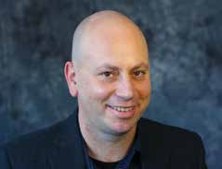

of his first book: “The Infrahuman: Tropes of Animality in Modern Jewish Literature,” which is currently under exclusive review with SUNY Press. The book deals with representations of Jewish people
as animals in major works of modern
of the Jews, the correlation he traces
is informal and marked not by an affirmation of universal human rights, but by attentiveness to the dehumanized aspects of Jewish existence.
Professor Pines’ current book project, “Children of Saturn: Jews and The Roots of Melancholia,” is currently under consideration with Fordham University Press, and his work on this material is forthcoming in Jewish Studies Quarterly. The book examines the notion of melancholia in its relation to Jews and modern Jewish identity by uncovering a constellation in which an entire array of themes and motifs play a part. Rather than analyzing melancholia exclusively as a psychological, artistic, or historical
phenomenon, Pines trace its inception in a trope that emerges from a retrospective projection of a primitive psychic or cosmic constitution that runs counter
to transcendence. In the pre-modern context melancholia implied a fall into

OUR FACULTY

self-estrangement in which the human being renounced his divine legacy and acknowledged no higher law than the world of earthly things. With the
modern Jewish authors that he examines, the self-estrangement characteristic
of melancholia is dislodged from its traditional theological moorings. Instead, it emerges as the primary channel of communication between human and earthly nature. In these terms, the modern Jewish authors that appropriated melancholia as a trope produced a “post- Jewish” identity.
epilogue compares medieval ideas about the relationship between divine and human bodies to those expressed in contemporary, popular esotericism. The epilogue of Tracing the Body Divine is also the beginning of her next
project, The Sacred Body in the New Age. This book focuses on North American New Age religion, examining esoteric conceptions of gender, embodiment, and sacred sexuality in contemporary North America. It explores conceptions of the sacred feminine in sexual expression
in three New Age groups employing
kabbalistically derived models of
addition, he has almost completed writing his next book, “Joseph Ibn Kaspi and the Meaning of History: The Bible as Historical Wisdom.” The first four chapters explore how, according to Kaspi, different conceptions of history operate in the Bible, and how this is reflected in his polemical response to Christian models of history.
Green presented an early version of this study at the 2015 meeting of the Association of Jewish Studies entitled: “Power, Prophecy and History in the Thought of Joseph Ibn Kaspi.” He will
present a section of the first chapter at the

embodiment and sexuality.
2016 meeting of the Association of Jewish
Studies entitled: “Joseph ibn Kaspi’s

Marla Segol
Marla Segol is an Associate Professor in both the Department of Jewish Thought and Department of Transnational Studies
Segol has also published articles on magic and astrology, on contemporary self-help literature, and on the idea of
the microcosm.
Maimonidean Polemic with Christianity in ‘the Scepter Shall Not Depart from Judah’ (Genesis 49:10).”

2016 Articles:

at UB. She serves as Undergraduate ›› “Maimonides on Courage,” Jewish Studies

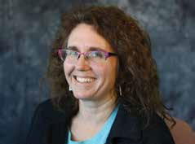

Advisor in the Department of Jewish Thought. Her research is in the fields of Kabbalah, Jewish magic, and the history of the body in religion. Her most recent book is Word and Image in Medieval Kabbalah: The Texts, Commentaries and Diagrams of the ‘Sefer Yetsirah’” (Palgrave, 2012.) She
is currently working on two more book projects, “Kabbalah’s Two Bodies” and “A Sourcebook on Jewish Letter Magic.”
In 2015-2016, Segol took a research leave to fully draft her new book: Tracing
the Body Divine, which begins with the controversial idea that medieval Jewish mystics believed in divine corporeality, and that this belief directly informed their understandings of the human body. The book focuses on key materials from the 5th-13th centuries, while the

Alex Green
Professor Alex Green is an Assistant Professor of Jewish Studies in the Department of Jewish Thought and the History Department at UB. He completed his PhD at the University of Toronto in the
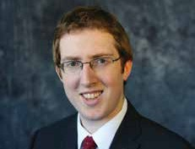

Department for the Study of Religion and his MA in Jewish Thought at the Hebrew University of Jerusalem. His research focuses on medieval Jewish philosophy, ethics, and the history of biblical interpretation.
While on research leave for the Spring 2016 semester, Professor Green’s manuscript, The Virtue Ethics of Levi Gersonides, was accepted for publication by Palgrave-MacMillan and is scheduled to be published in the fall of 2016. In
Quarterly 22, no. 2 (2015): 162-83
›› “A Portrait of Spinoza as a Maimonidean Reconsidered,” Shofar 34, no. 1 (2015):
81-106
›› “MacIntyre and Nussbaum on Diversity, Liberalism and Christianity,” Perspectives on Political Science (forthcoming)

Lilia Dolgopolskaia
Lilia Dolgopolskaia (MA in Hebrew Language and Second Language Acquisition) is an adjunct instructor of Modern Hebrew Language. The
Department offers four semesters of Modern Conversational Hebrew, from the beginner level, and hopes to offer more advanced levels of Modern Hebrew, as well as Biblical Hebrew, in the future.

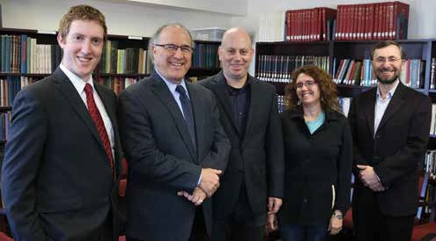2015-2016 LECTURES AND CONFERENCES

The Impact of Maimonides

On November 19, 2015, the Department of Jewish Thought hosted a one-day conference entitled “The Impact for Maimonides.” The conference featured a panel of four scholars who have
recently published books on the medieval Jewish thinker, Moses Maimonides.
Approximately 100 people attended the conference. The audience included undergraduate students, graduate students, faculty from different
departments at UB, community members, and local rabbis.

The Department of Jewish Thought faculty. From left to right: Alex Green, Richard Cohen, Noam Pines, Marla Segol, and Sergey Dolgolopski.

Panelists
›› Moshe Halbertal, Gruss Professor at NYU School of Law and a Professor of Jewish Thought and Philosophy at Hebrew University
›› Lawrence Kaplan, Associate Professor in the Department of Jewish Studies at McGill University
›› Kenneth Hart Green, Professor in the Department for the Study of Religion and the Centre for Jewish Studies at the University of Toronto
›› James Diamond, the Joseph & Wolf Lebovic Chair of Jewish Studies at the University of Waterloo.

Conference Schedule Samuel Friedman Library:
›› 11:00am: Kenneth Hart Green, “Why Maimonides Was Controversial”
›› 1:00pm: Moshe Halbertal, “Emotion and the Law: Maimonides’ Conception of Mourning”
›› 2:15pm: Lawrence Kaplan, “Love and Fear of God in the Writings of Maimonides According to Rabbi Joseph B. Soloveitchik”
›› 3:30pm: James Diamond, “Nahmanides vs Maimonides on Memory and The Shaping of Jewish Identity”

Temple Beth Tzedek:
›› 7:30pm: Featured panel entitled “Why Read Maimonides Today.” Professor Alex Green of the Department of Jewish Thought moderated the panel. Each
visiting lecturer gave brief presentations, followed by an audience Q&A. Books were available for purchase, provided by Talking Leaves Books.

The Law in the Work of Franz Kafka
From his early writings including “The Judgment,” through The Trial, and to later works such as The Castle and the oft- neglected “The Animal in the Synagogue,” the theme of “law” permeates the work
of Franz Kafka. On April 4-5th 2016, six panelists gathered at UB to explore some of the literary, philosophical, and
theological aspects of the law in Kafka’s writings, suggesting ways to situate it within his work as well as within the general context of Jewish thought and modernist literature.

Panelists
›› Paul North, Professor Germanic Languages and Literatures and Director of Undergraduate Studies at Yale University
›› Nitzan Lebovic, Professor of History at Lehigh University
›› Max Pensky, Professor of Philosophy at SUNY Binghamton
›› Richard Cohen, Professor of Jewish Thought and Professor of Philosophy at UB
›› Sergey Dolgopolski, Chair of Jewish Thought at UB
›› Noam Pines, Assistant Professor of Jewish Thought at UB

Conference Schedule April 4th:
›› 9:00am: Reception and Opening Remarks
›› 9:30am: Nitzan Lebovic, “The Law of No Man’s Land: On Kafka and Porous Borders”
›› 11:00am: Richard Cohen, “Pusillanimous Kafka: A Sad Case”
›› 2:00pm: Sergey Dolgopolski, “Anteriorities: Kafka’s Critique of the Political in the Talmud”
›› 3:30pm: Max Pensky, “Spooky Action at a Distance: Kafka and the Law
of Spacetime”
›› 8:00pm: Roundtable Panel “Kafka in Our Time”

April 5th:
›› 9:00am: Paul North, “To Defraud but Not to Deceive”
›› 10:30am: Noam Pines, “On Shechita in Kafka’s The Trial”
›› 12:30pm: Conclusion and Roundtable Discussion

NEW AND UPCOMING BOOK PUBLICATIONS

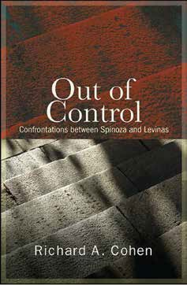
Out of Control: Confrontations between Spinoza and Levinas
by Richard Cohen
After the end of superstitious religion, what is the meaning of the world? Baruch Spinoza’s answer is truth; Emmanuel Levinas’s is goodness: science versus ethics. In Out of Control, Richard A. Cohen brings this debate to life, providing a nuanced exposition
of Spinoza and Levinas and the confrontations between them in ethics, politics, science, and religion.

Spinoza is the control, the inexorable defensive logic of administrative rationality, where freedom is equated to

The Virtue of Ethics of Levi Gersonides
by Alex Green
Alex Green’s new book argues that Levi Gersonides articulates a unique model of virtue ethics among medieval Jewish thinkers. Gersonides is recognized
by scholars as one of the most innovative Jewish philosophers of the medieval period.

His first model of virtue is a response to the seemingly capricious forces of luck through training in endeavor,
diligence, and cunning aimed at physical self-preservation. His second model of virtue is altruistic in nature, based on the human imitation of God as creator

necessity—a seventeenth-century glimpse of Orwellian doublespeak and Big Brother. Levinas is the way out: transcendence not of God, being, and logic but of the other person experienced as moral obligation. To alleviate the suffering of others— nothing is more important! Spinoza wagers everything on mathematical
truth, discarding the rest as ignorance and illusion; for Levinas, nothing surpasses the priorities of morality and justice, to create a world in which humans can be human and not numbers or consumers, drudges or robots.

Situating these two thinkers in today’s context, Out of Control responds to the fear of dehumanization in a world flattened by the alliance of positivism
and plutocracy. It offers a non-ideological ethical alternative, a way out and up, in the nobility of one human being helping another, and the solidarity that moves from morality to justice.

“Cohen’s work here is nothing short of spectacular. His analysis of the
mathematical and scientific foundations of Spinoza’s philosophy is exemplary.
Lucidly, meticulously, and with very disciplined analysis he conveys the
Cohen Explores the fundamental confrontations between Spinoza and Levinas in ethics, politics, science, and religion.

force, power, and influence of Spinoza’s philosophy on contemporary religious thought.” — Richard I. Sugarman, University of Vermont.

“Richard Cohen has managed to not merely bring these two notoriously difficult philosophers into conversation with each other, but to do so in an extremely readable way. Indeed, he
is able to explain extremely difficult philosophical disputes with clarity and to convey a palpable sense of excitement.” — Robert Erlewine, author of Monotheism and Tolerance: Recovering a Religion
of Reason.

of the laws of the universe for no self-
interested benefit, leading humans to imitate God through the virtues of
loving-kindness, grace, and beneficence.

Both these models are amplified through the institutions of the kingship and the priesthood, which serve to actualize physical preservation and beneficence on a larger scale, amounting to recognition of the political necessity for a division of powers.

STUDENT PROFILE | JORDAN EINHORN

Luke Heuskin ›› Jordan Einhorn has always been interested in Judaism and religious philosophy, but it was a mandatory Honors College seminar, Sergey Dologopolski’s JDS 284: Justice in Bibles, Law and Philosophy, that set
him on the path toward studying Jewish thought in an academic setting.

Einhorn, a White Plains native and junior at UB majoring in Political Science and dual minoring in Education and Jewish Studies, says that after taking this course, “I ended up going to an open house
event for the department in the Samuel Friedman library, and within five minutes of meeting Marla Segol, she had the paperwork ready for me to sign.”

Since then, he has “jumped into the curriculum.” This fall he is studying Maimonides acclaimed work, Guide of the Perplexed, with Alex Green.

“There’s so much information and meaning to be found in nearly every well- known book of Jewish thought, the Guide being just one,” Einhorn says.

Though the formidable size and scope of Maimonides’ work would be inaccessible “in a broader curriculum with less focus,” Einhorn praises the department for doing it justice with a specialized course.

10
“I think everyone would agree that one semester is not enough time to truly understand everything about the Guide. The department gives it the attention it deserves and allows students to spend over three months studying the Guide on its own.”

Einhorn has also been impressed by the breadth and diversity of content in the Department of Jewish Thought curriculum. In addition to discussing great Jewish philosophers, he has
encountered a wide array of texts from non-Jewish traditions.

“In addition to learning about Maimonides or Rashi, I’ve spent time doing readings and engaging in discussions on individuals such as
Aristotle, Augustine, Aquinas, and Al- Ghazzali to name a few,” Einhorn says. “I’ve even spent time learning about Pablo Picasso!”

The department encourages students to engage deeply with texts through a
rigorous method rooted in Judaism’s rich exegetical tradition, and in doing so helps to hone critical skills and foster open- minded dialogue.

“When we read works or talk about ideas that contradict preconceived ideas about Judaism or theology,” Einhorn explains, “it forces all of us to either figure out a way to reconcile that contradiction, or
to come to terms with the fact different worldviews and interpretations
of the same phenomenon can exist independently of one another.”

The coursework requires students to approach complex theological questions from many angles, and as a result students can walk away from the same class with vastly different interpretations of the answers to those issues.

“It’s always interesting to see how everyone works their way through
reconciling various contradictions, or
accepting that such a reconciliation
may not exist for that particular issue,” Einhorn says. “I think this is a good thing as it facilitates dialogue, culturalism, and, ultimately, pluralism.

No matter what conclusions one comes to about the texts themselves, there’s no denying that Jewish theology and
philosophy can be “challenging terrain.” For Einhorn, the process of uncovering

“There’s so much information and meaning to be found in nearly every well-known book of Jewish thought, the Guide being just one.”

Jordan Einhorn

meaning and working toward common understanding as a class is one of the most rewarding parts of studying in the Department of Jewish Thought.

“Whether it’s a medieval exegesis on the implications of law or a 2015 essay which discusses reworking the way modern readers approach the Talmud, a lot of readings in JDS classes can be
difficult,” he says. “I think this ultimately helps us and makes us better scholars of Jewish tradition. There’s nothing better than working through a particularly challenging reading with your classmates and eventually coming to an understanding that very few people had at the beginning.”

Einhorn describes his professors in the Department of Jewish Thought as
passionate experts who are committed to their students’ personal and
academic progress.

“I’ve always felt comfortable going to them and they clearly take a vested interest in my academic, individual, and professional growth,” he says. “Doing well in a class is so much easier when the professor is invested in their students’ success, and the professors in the department have absolutely demonstrated that.”
2016 Jewish Thought

LAST LOOK
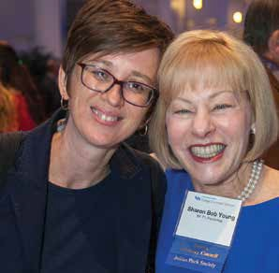
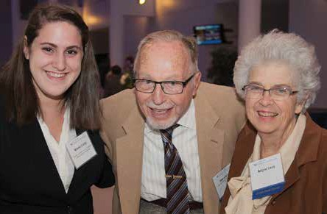

How to Support the Department of Jewish Thought

Ruth and Isadore Bob Fellowship Fund
Thank you to Sharon Bob Young, BA ’71, for her generous support of the
department through the Ruth and Isadore Bob Fellowship Fund. This stipend was created to support a UB doctoral student working in an academic area that touches upon Jews or Judaism. This year’s recipient is Emina Melonic.

The Harold J. and Arlyne G. Levy Award
Thanks to the generous support of Harold J. Levy, MD ’46, and Mrs. Arlyne
G. Levy, the department is able to award a sophomore, junior or senior student, who has demonstrated outstanding scholarship and commitment to the study of Jewish culture and heritage a
scholarship to support their studies. This year’s recipient is Nicole Caine.

TZEDAKAH: WAYS TO SUPPORT THE DEPARTMENT OF JEWISH THOUGHT
The newly established Department of Jewish Thought stands at a critical point as it expands its efforts to attract faculty and students, develop academic and community outreach programs, and build its infrastructure. To realize the vision and potential of this new department, we seek your help.

With your support, we can offer:
›› Student scholarships and fellowships
›› Lectures, workshops and conferences for students and the community
›› Materials for the library
›› Adult education programs
›› Visiting professorships
Opportunities for naming professorships, lecture series, research funds, fellowships and scholarships are available.

For more information on supporting the department, please contact:

College of Arts and Sciences Office of Philanthropy and Alumni Engagement
810 Clemens Hall
Buffalo, NY 14260
716-645-0850

http://www.buffalo.edu/giving/ jewishthought

Thanks to you...
“Hello! My name is Nicole Caine and I’m a senior at The University at Buffalo. My major is Global Gender Studies with a minor in Jewish Studies. I’m originally from Cleveland, OH, but have been lucky enough to call Buffalo my home for the past few years! Through the Department of Jewish Thought, I’ve found a place where I can learn more about my own culture and roots. The classes I have taken (and am currently taking) have not only given me a deeper understanding of my own religion, but have helped to guide me on a path to the future I want.”

12 2016 Jewish Thought
712 Clemens Hall Buffalo, New York 14260
Non Profit Org.
U.S. POSTAGE
PAID
Buffalo, NY Permit No. 311

Discover their Research
jewishthought.buffalo.edu
http://jewishthought.buffalo.edu/
JEWISH
THOUGHT
Newsletter 2015–2016

